2020暑期多校联合训练的常见问题回答（FAQ）

The Tower
Time Limit: 2000/1000 MS (Java/Others) Memory Limit: 262144/262144 K (Java/Others)
Total Submission(s): 1170 Accepted Submission(s): 417
Special Judge
Problem Description
The Tower shows a tall tower perched on the top of a rocky mountain. Lightning strikes, setting the building alight, and two people leap from the windows, head first and arms outstretched. It is a scene of chaos and destruction.
There is a cone tower with base center at (0, 0, 0), base radius r and apex (0, 0, h). At time 0 , a point located at (x0, y0, z0) with velocity (vx, vy, vz). What time will they collide? Here is the cone tower.
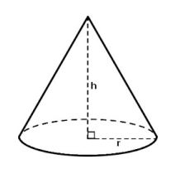

Input
The first line contains testcase number T (T ≤ 1000), For each testcase the first line contains spaceseparated real numbers r and h (1 ≤ r, h ≤ 1000) — the base radius and the cone height correspondingly.
For each testcase the second line contains three real numbers x0, y0, z0 (0 ≤ |x0|, |y0|, z0 ≤ 1000). For each testcase the third line contains three real numbers vx, vy, vz (1 ≤ v2x + v2y + v2z ≤ 3 × 106). It is guaranteed that at time 0 the point is outside the cone and they will always collide.

Output
For each testcase print Case i : and then print the answer in one line, with absolute or relative error not exceeding 10−6

Sample Input
2
1 2
1 1 1
-1.5 -1.5 -0.5
1 1
1 1 1
-1 -1 -1

Sample Output
Case 1: 0.3855293381
Case 2: 0.5857864376

Source
2018CCPC吉林赛区（重现赛）- 感谢北华大学

Recommend
chendu | We have carefully selected several similar problems for you: 6742 6741 6740 6739 6738

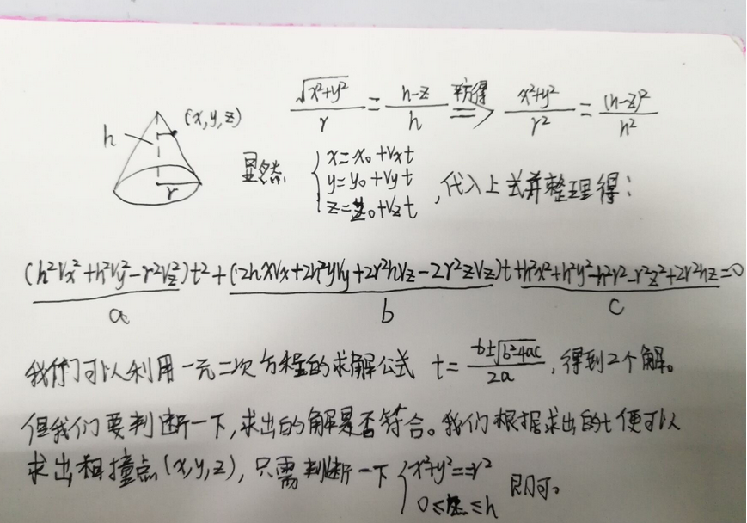

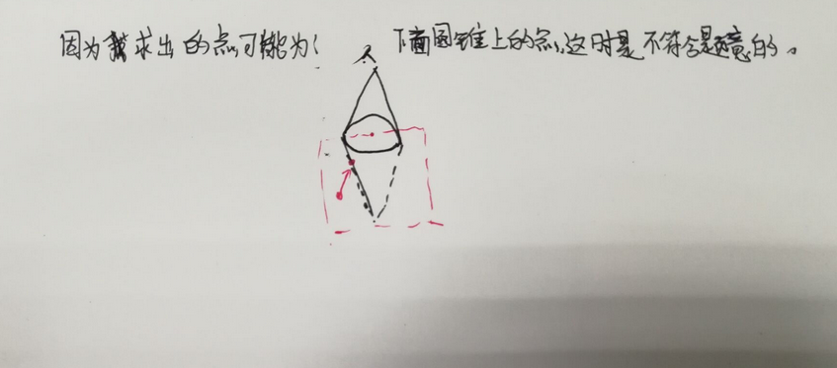

#include<map>
#include<set>
#include<cmath>
#include<queue>
#include<stack>
#include<cstdio>
#include<vector>
#include<bitset>
#include<string>
#include<cstdlib>
#include<cstring>
#include<fstream>
#include<sstream>
#include<iomanip>
#include<iostream>
#include<algorithm>
#include<functional>
//#include<bits/stdc++.h>
#define INF 0x3f3f3f3f //1061109567
#define llINF 9223372036854775807
#define pi 3.141592653589793
#define ll long long
using namespace std;
int main()
{
int t;
scanf("%d",&t);
int kk=0;
while(t--)
{ kk++;
double r,h;
double x0,y0,z0;
double vx,vy,vz;
scanf("%lf %lf",&r,&h);
scanf("%lf %lf %lf",&x0,&y0,&z0);
scanf("%lf %lf %lf",&vx,&vy,&vz);
double k1=h*h*vx*vx+h*h*vy*vy-r*r*vz*vz;
double k2=(double)2.0*h*h*vx*x0+2*h*h*vy*y0+2*r*r*h*vz-2*r*r*z0*vz;
double k3=h*h*x0*x0+h*h*y0*y0-h*h*r*r-r*r*z0*z0+2*r*r*h*z0;
double hehe=sqrt(k2*k2-(double)4.0*k1*k3);
double di=k1+k1;
double t1=-k2+hehe; t1=t1/di;
double t2=-k2-hehe; t2=t2/di;
double ans=0;
if(t1>0)
{
double xx=x0+vx*t1;
double yy=y0+vy*t1;
double zz=z0+vz*t1;
if(zz>=0&&zz<=h&&(xx*xx+yy*yy<=r*r))
{
ans=t1;
}
}
if(t2>0)
{

double xx=x0+vx*t2;
double yy=y0+vy*t2;
double zz=z0+vz*t2;
if(zz>=0&&zz<=h&&(xx*xx+yy*yy<=r*r))
{
ans=t2;
}
}
printf("Case %d: ",kk);
printf("%.10lf\n",ans);
}
return 0;
}

